de ***TỔNG HỢP BÀI LÀM ĐỀ THI C INTRO CÁC KHÓA***

By Hoanh only Hoanh

**Đề K54**



#include<stdio.h>

#include<string.h>

#include<stdlib.h>

#define qa 5

typedef struct qt

{

char cauhoi[120] ;

char pa1[30];

char pa2[30];

char pa3[30];

int dapan;

}qt_type ;

void nhap(qt_type*K,int n)

{

int i;

for(i=0;i<n;i++)

{

printf("Moi ban nhap cau hoi %d:\n",i+1);

fflush(stdin);

gets(K[i].cauhoi);

printf("Dap an 1 :_");

gets(K[i].pa1);

printf("Dap an 2 :_");

gets(K[i].pa2);

printf("Dap an 3 :_");

gets(K[i].pa3);

printf("dap an dung :\n");

scanf("%d",&K[i].dapan);

while(K[i].dapan<1||K[i].dapan>3)

{

printf("nhap lai dap an dung :\n");

scanf("%d",&K[i].dapan);

}

}

}

void inra(qt_type*K,int n)

{

int a;

printf("Moi ban nhap cau hoi muon in ra man hinh :\n");

scanf("%d",&a);

while(a<1||a>5)

{

printf("Ko hop le ! Moi ban nhap lai so hieu cau hoi muon in ra man hinh :\n");

scanf("%d",&a);

}

printf("%s\n",K[a-1].cauhoi);

printf("1.%-30s2.%-30s3.%-30s",K[a-1].pa1,K[a-1].pa2,K[a-1].pa3);

}

void daodapan(qt_type*K,int n)

{

int j,change;

qt_type a;

printf("Moi ban nhap cau hoi muon dao dap an\n");

scanf("%d",&j);

while(j<1||j>5)

{

printf("Lua chon ko hop le ! Moi ban nhap lai cau hoi muon dao dap an :\n");

scanf("%d",&j);

}

printf("Moi ban nhap dap an muon dao :\n");

scanf("%d",&change);

while(change<1||change>3||change==K[j-1].dapan)

{

printf("Lua chon ko hop le ! Moi ban nhap lai dap an muon dao :\n");

scanf("%d",&change);

}

switch(K[j-1].dapan)

{

case 1:

if(change==2)

{

strcpy(a.pa1,K[j-1].pa1);

strcpy(K[j-1].pa1,K[j-1].pa2);

strcpy(K[j-1].pa2,a.pa1);

}

else

{

strcpy(a.pa1,K[j-1].pa1);

strcpy(K[j-1].pa1,K[j-1].pa3);

strcpy(K[j-1].pa3,a.pa1);

}

K[j-1].dapan=change;

break;

case 2:

if(change==1)

{

strcpy(a.pa1,K[j-1].pa2);

strcpy(K[j-1].pa2,K[j-1].pa1);

strcpy(K[j-1].pa1,a.pa1);

}

else

{

strcpy(a.pa1,K[j-1].pa2);

strcpy(K[j-1].pa2,K[j-1].pa3);

strcpy(K[j-1].pa3,a.pa1);

}

K[j-1].dapan=change;

break;

default:

{

if(change==1)

{

strcpy(a.pa1,K[j-1].pa3);

strcpy(K[j-1].pa3,K[j-1].pa1);

strcpy(K[j-1].pa1,a.pa1);

}

else

{

strcpy(a.pa1,K[j-1].pa3);

strcpy(K[j-1].pa3,K[j-1].pa2);

strcpy(K[j-1].pa2,a.pa1);

}

K[j-1].dapan=change;

}

}

printf("%s\n",K[j-1].cauhoi);

printf("1.%-30s2.%-30s3.%-30s",K[j-1].pa1,K[j-1].pa2,K[j-1].pa3);

}

void gameplay(qt_type*K,int n)

{

int i,j,x=0;

int ch[3],kotae[3];

char ten[30];

for(i=0;i<3;i++)

{

x=0;

printf("Moi nhap ten nguoi choi %d :_",i+1);

fflush(stdin); gets(ten);

printf("Moi chon 3 cau hoi muon thi :\n");

for(j=0;j<3;j++)

{

scanf("%d",&ch[j]);

while(ch[j]<1||ch[j]>5||ch[j]==ch[j-1]||ch[j]==ch[j-2])

{

printf("Cau hoi da chon ko hop le, moi ban chon lai !\n");

scanf("%d",&ch[j]);

}

}

for(j=0;j<3;j++)

{

printf("%s\n",K[ch[j]-1].cauhoi);

printf("1.%-30s2.%-30s3.%-30s",K[ch[j]-1].pa1,K[ch[j]-1].pa2,K[ch[j]-1].pa3);

printf("\nCau tra loi cua ban la :__");

scanf("%d",&kotae[j]);

while (kotae[j]<1||kotae[j]>3)

{

printf("Lua chon ko hop le ! Moi ban nhap lai dap an :\n");

scanf("%d",&kotae[j]);

}

}

printf("Nguoi choi :%s\n",ten);

for(j=0;j<3;j++)

{

if(x==0)

{

printf("%-10s%-15s%-10s%-5s\n","Cau hoi","P.a lua chon","P.a dung","diem");

x=1;

}

{

if(K[ch[j]-1].dapan==kotae[j])

printf("%-10d%-15d%-10d%-5d\n",ch[j],kotae[j],K[ch[j]-1].dapan,1);

else printf("%-10d%-15d%-10d%-5d\n",ch[j],kotae[j],K[ch[j]-1].dapan,0);

}

}

}

}

int main()

{

int m,n=5;

qt_type K[qa];

while(m!=5)

{

printf("\nMenu\n1.Tao cau hoi\n2.In cau hoi\n3.Dao dap an\n4.Choi game\n5.Thoat\n");

scanf("%d",&m);

switch(m)

{

case 1:

nhap(K,n);

break;

case 2:

inra(K,n);

break;

case 3:

daodapan(K,n);

break;

case 4:

gameplay(K,n);

break;

case 5: printf("Goodbye !____");

break;

default : printf("Please enter again !\n");

}

}

}

**Đề K55(2)**



#include<stdio.h>

#include<math.h>

typedef struct times

{

int hour;

int minute;

}time_t;

typedef struct com_type

{

int number;

int free;

time_t beginTime;

time_t endTime;

long fee;

int time_used;

}computer;

void khoitao(computer *K, int n)

{

int i;

printf("%-3s %-5s\t%-5s\t%-5s\t%-10s\t%-10s\n","STT","status","begin","end","fee","time_used");

for(i=0;i<10;i++)

{

K[i].number=i+1;

K[i].free=1;

K[i].beginTime.hour = 0;

K[i].beginTime.minute = 0;

K[i].endTime.hour = 0;

K[i].endTime.minute = 0;

K[i].fee=0;

K[i].time_used=0;

printf("%-3d %-5s\t%-d0:%-d0\t%-d0:%-d0\t%-10ld\t%-10d\n",K[i].number,"Free",K[i].beginTime.hour,K[i].beginTime.minute,K[i].endTime.hour,K[i].endTime.minute,K[i].fee,K[i].time_used);

}

}

int invalidTime(time_t a)

{

if(a.hour<0||a.hour>23||a.minute<0||a.minute>59)

{

return 1;

}

else return 0;

}

int timeCompare(time_t a,time_t b)

{

if(a.hour>b.hour)

{

return 1;

}

if(a.hour<b.hour)

{

return -1;

}

if(a.hour==b.hour)

{

if(a.minute>b.minute)

{

return 1;

}

if(a.minute<b.minute)

{

return -1;

}

if(a.minute==b.minute)

{

return 0;

}

}

}

void dungmay(computer*K,int n)

{

int choose;

printf("Chon may muon dung : \n");

scanf("%d",&choose);

while(choose<0||choose>10)

{

printf("May ko hop le moi nhap lai\n");

scanf("%d",&choose);

}

if(K[choose-1].free==1)

{

printf("May hop le !");

K[choose-1].free=0;

printf("Moi nhap thoi gian bat dau gio:phut\n");

scanf("%d %d",&K[choose-1].beginTime.hour,&K[choose-1].beginTime.minute);

while(invalidTime(K[choose-1].beginTime)==1)

{

printf("Moi nhap lai thoi gian bat dau gio:phut\n");

scanf("%d %d",&K[choose-1].beginTime.hour,&K[choose-1].beginTime.minute);

}

}

else printf("May da co nguoi su dung, moi ban quay lai sau !");

}

void nghichoi(computer *K, int n)

{

int stop;

printf("Moi nhap may muon tat !\n");

scanf("%d",&stop);

while(stop<1||stop>10)

{

printf("KO hop le,moi nhap lai may muon tat !");

scanf("%d",&stop);

}

switch(K[stop-1].free)

{

case 1: printf("May chua dc bat, vui long chon chuc nang 2 de bat may hoac 3 de tat may khac");

break;

case 0:

printf("Moi nhap thoi gian ket thuc :\n");

scanf("%d %d",&K[stop-1].endTime.hour,&K[stop-1].endTime.minute);

while(invalidTime(K[stop-1].endTime)==1)

{

printf("Moi nhap lai thoi gian ket thuc gio:phut\n");

scanf("%d %d",&K[stop-1].endTime.hour,&K[stop-1].endTime.minute);

}

while(timeCompare(K[stop-1].endTime,K[stop-1].beginTime)<0)

{

printf("Moi nhap lai thoi gian ket thuc gio:phut\n");

scanf("%d %d",&K[stop-1].endTime.hour,&K[stop-1].endTime.minute);

}

K[stop-1].free=1;

printf("HOA DON THANH TOAN\n");

printf("Thoi gian bat dau: %d:%d\n",K[stop-1].beginTime.hour,K[stop-1].beginTime.minute);

printf("Thoi gian ket thuc: %d:%d\n",K[stop-1].endTime.hour,K[stop-1].endTime.minute);

printf(" So phut su dung la : %d\n",abs(K[stop-1].endTime.minute-K[stop-1].beginTime.minute)+(K[stop-1].endTime.hour-K[stop-1].beginTime.hour)*60);

printf("So tien phai tra la : %ld\n",100*(abs(K[stop-1].endTime.minute-K[stop-1].beginTime.minute)+(K[stop-1].endTime.hour-K[stop-1].beginTime.hour)*60));

K[stop-1].time_used+=abs(K[stop-1].endTime.minute-K[stop-1].beginTime.minute)+(K[stop-1].endTime.hour-K[stop-1].beginTime.hour)*60;

K[stop-1].fee+=K[stop-1].time_used*100;

break;

}

}

void chuyenmay(computer *K, int n)

{

int now,then;

computer a;

printf("Nhap may ban dang su dung :\n");

scanf("%d",&now);

while(K[now-1].free==1||now<1||now>10)

{

printf("Nhap lai may ban dang su dung :\n");

scanf("%d",&now);

}

printf("Nhap may ban muon chuyen den :\n");

scanf("%d",&then);

while(K[then-1].free==0||then<1||then>10||then ==now)

{

printf("KO hop le! Moi nhap lai may ban muon chuyen den :\n");

scanf("%d",&then);

}

a.beginTime=K[then-1].beginTime;

K[then-1].beginTime=K[now-1].beginTime;

K[now-1].beginTime.hour=0;

K[now-1].beginTime.minute=0;

a.free=K[then-1].free;

K[then-1].free=K[now-1].free;

K[now-1].free=a.free;

}

void trangthai(computer *K, int n)

{

int i;

printf("%-3s %-5s\t%-5s\t%-5s\t%-10s\t%-10s\n","STT","status","begin","end","fee","time_used");

for(i=0;i<10;i++)

{

if(K[i].free==1)

printf("%-3d %-5s\t%-2d:%-2d\t%-2d:%-2d\t%-10ld\t%-10d\n",K[i].number,"Free",K[i].beginTime.hour,K[i].beginTime.minute,K[i].endTime.hour,K[i].endTime.minute,K[i].fee,K[i].time_used);

else

printf("%-3d %-5s\t%-2d:%-2d\t%-2d:%-2d\t%-10ld\t%-10d\n",K[i].number,"Busy",K[i].beginTime.hour,K[i].beginTime.minute,K[i].endTime.hour,K[i].endTime.minute,K[i].fee,K[i].time_used);

}

}

void doanhthu(computer *K, int n)

{

int i,j;

computer K2[10],a;

for(i=0;i<10;i++)

{

K2[i]=K[i];

}

for(j=n-1;j>=0;j--)

{

for(i=0;i<j;i++)

{

if(K2[i].fee<K2[i+1].fee)

{

a=K2[i];

K2[i]=K2[i+1];

K2[i+1]=a;

}

}

}

printf("%-3s %-5s\t%-5s\t%-5s\t%-10s\t%-10s\n","STT","status","begin","end","fee","time_used");

for(i=0;i<10;i++)

{

if(K2[i].free==1)

printf("%-3d %-5s\t%-2d:%-2d\t%-2d:%-2d\t%-10ld\t%-10d\n",K2[i].number,"Free",K2[i].beginTime.hour,K2[i].beginTime.minute,K2[i].endTime.hour,K2[i].endTime.minute,K2[i].fee,K2[i].time_used);

else

printf("%-3d %-5s\t%-2d:%-2d\t%-2d:%-2d\t%-10ld\t%-10d\n",K2[i].number,"Busy",K2[i].beginTime.hour,K2[i].beginTime.minute,K2[i].endTime.hour,K2[i].endTime.minute,K2[i].fee,K2[i].time_used);

}

}

void goiy(computer*K,int n)

{

int i,min;

min=K[0].time_used;

for(i=1;i<10;i++)

{

if(min>K[i].time_used)

{

min=K[i].time_used;

}

}

for(i=0;i<10;i++)

{

if(K[i].time_used==min&&K[i].free==1)

{

printf("May %d voi %d gio su dung hom nay va dang free la 1 lua chon hop ly \n",i+1,min);

}

}

}

int main()

{

int m,n=10;

computer K[10];

int i;

while(m!=8)

{

printf("\nMenu\n1.Khoi tao du lieu\n2.Dung may\n3.Nghi choi\n4.Chuyen may\n5.In ra trang thai phong may\n6.In ra thong tin phong may sap xep theo chieu giam dan so tien thu dc tu dau ngay\n7.Goi y dung may\n8.Thoat\n");

scanf("%d",&m);

switch(m)

{

case 1:

khoitao(K,n);

break;

case 2:

dungmay(K,n);

break;

case 3:

nghichoi(K,n);

break;

case 4:

chuyenmay(K,n);

break;

case 5:

trangthai(K,n);

break;

case 6:

doanhthu(K,n);

break;

case 7:

goiy(K,n);

break;

case 8:

printf("Goodbye!.......");

break;

default : printf("Please Enter Again !");

}

}

}

**Đề K55(1)**

#include<stdio.h>

#include<string.h>

#include<stdlib.h>

#define MAX 10

typedef struct

{

char hoten[30];

int diem[5];

}ketquathidau;

void nhap(ketquathidau*vdv,int n)

{

int i;

for(i=0;i<n;i++)

{

printf("Nhap ten vdv [%d]",i+1);

fflush(stdin);

gets(vdv[i].hoten);

}

}

void thidau(ketquathidau*vdv,int n)

{

int i,j;

for(j=0;j<=4;j++)

{

printf("Luot thi dau thu %d :\n",j+1);

for(i=0;i<n;i++)

{

printf("Van dong vien %d dat duoc :\n",i+1);

scanf("%d",&vdv[i].diem[j]);

while(vdv[i].diem[j]<0||vdv[i].diem[j]>10)

{

printf("diem ko hop le, moi nhap lai diem vdv %d :\n",i+1);

scanf("%d",&vdv[i].diem[j]);

}

}

}

printf("%-30s %-5d %-5d %-5d %-5d %-5d\n","Ho ten",1,2,3,4,5);

for(i=0;i<n;i++)

{

printf("%-30s %-5d %-5d %-5d %-5d %-5d\n",vdv[i].hoten,vdv[i].diem[0],vdv[i].diem[1],vdv[i].diem[2],vdv[i].diem[3],vdv[i].diem[4]);

}

}

void ranking(ketquathidau*vdv,int n)

{

int i,j;

int sum[5];

int max,max1,max2;

ketquathidau K[MAX];

for(i=0;i<n;i++)

{

sum[i]=0;

for(j=0;j<=4;j++)

{

sum[i]+=vdv[i].diem[j];

}

}

max=sum[0];

for(i=0;i<n;i++)

{

if(max<sum[i])

{

max=sum[i];

}

}

max1=0;

for(i=0;i<n;i++)

{

if(max1<sum[i]&&sum[i]<max)

{

max1=sum[i];

}

}

max2=0;

for(i=0;i<n;i++)

{

if(max2<sum[i]&&sum[i]<max1)

{

max2=sum[i];

}

}

for(i=0;i<n;i++)

{

if(sum[i]==max)

K[0]=vdv[i];

if(sum[i]==max1)

K[1]=vdv[i];

if(sum[i]==max2)

K[2]=vdv[i];

//printf("%-30s %-5s %-5d\n",vdv[i].hoten,"Bronze",max2);

}

printf("%-30s %-5s %-5d\n",K[0].hoten,"Gold",max);

printf("%-30s %-5s %-5d\n",K[1].hoten,"Silver",max1);

printf("%-30s %-5s %-5d\n",K[2].hoten,"Bronze",max2);

}

superadc(ketquathidau*vdv,int n)

{

int i,j;

int dem=0;

for(i=0;i<n;i++)

{

for(j=0;j<3;j++)

{

if(vdv[i].diem[j]==vdv[i].diem[j+1]&&vdv[i].diem[j]==vdv[i].diem[j+2]&&vdv[i].diem[j]==10)

{

if(dem==0)

{

printf("Super ADC :\n");

printf("%-30s\n",vdv[i].hoten);

dem++;

}

else

{

printf("%-30s\n",vdv[i].hoten);

break;

}

}

}

}

}

int main()

{

ketquathidau vdv[MAX];

int m,n;

int j;

while(m!=5)

{

printf("\nMenu\n1.Dang ki VDV thi dau\n2.Thi dau\n3.Ranking\n4.Super Ad Carry\n5.Thoat\n");

scanf("%d",&m);

switch(m)

{

case 1:

printf("Nhap so van dong vien tham gia thi dau :\n");

scanf("%d",&n);

while(n<0||n>10)

{

printf("So luong ko hop le, moi nhap lai !\n");

scanf("%d",&n);

}

nhap(vdv,n);

break;

case 2:

thidau(vdv,n);

break;

case 3:

ranking(vdv,n);

break;

case 4:

superadc(vdv,n);

break;

case 5:

printf("Goodbye.........");

break;

default : printf("Please Enter Again!");

}

}

}

**Đề K60**

￼

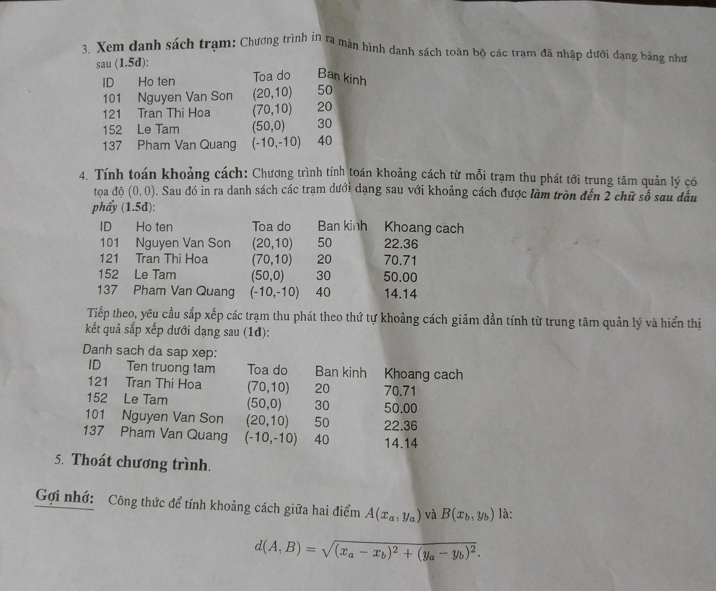

#include<stdio.h>

#include<string.h>

#include<stdlib.h>

#include<math.h>

typedef struct

{

int id;

char name[30];

float distance;

int x,y;

int r;

}station;

void nhap(station*list,int n)

{

int i;

for(i=0;i<n;i++)

{

printf("id tram[%d] = ",i+1);

scanf("%d",&list[i].id);

printf("ten truong tram[%d] = ",i+1);

fflush(stdin);

gets(list[i].name);

printf("Toa do x[%d] = ",i+1);

scanf("%d",&list[i].x);

printf("Toa do y[%d] = ",i+1);

scanf("%d",&list[i].y);

printf("ban kinh hdong[%d] = ",i+1);

scanf("%d",&list[i].r);

while(list[i].r<0)

{

printf("Nhap lai ban kinh hoat dong > 0 va <100\n ");

scanf("%d",&list[i].r);

}

while(list[i].r>100)

{

printf("Nhap lai ban kinh hoat dong > 0 va <100\n ");

scanf("%d",&list[i].r);

}

list[i].distance=sqrt(pow(list[i].x,2)+pow(list[i].y,2));

}

}

void nhapthem(station*list,int n,int j)

{

int i;

for(i=n-j;i<n;i++)

{

fflush(stdin);

printf("id tram[%d] = ",i+1);

scanf("%d",&list[i].id);

printf("ten truong tram[%d] = ",i+1);

fflush(stdin);

gets(list[i].name);

printf("Toa do x[%d] = ",i+1);

scanf("%d",&list[i].x);

printf("Toa do y[%d] = ",i+1);

scanf("%d",&list[i].y);

printf("ban kinh hdong[%d] = ",i+1);

scanf("%d",&list[i].r);

while(list[i].r<0)

{

printf("Nhap lai ban kinh hoat dong > 0 va <100\n ");

scanf("%d",&list[i].r);

}

while(list[i].r>100)

{

printf("Nhap lai ban kinh hoat dong > 0 va <100\n ");

scanf("%d",&list[i].r);

}

list[i].distance=sqrt(pow(list[i].x,2)+pow(list[i].y,2));

}

}

void inra(station*list,int n)

{

int i;

printf("%-10s | %-20s | %-10s | %-10s |\n","ID","Ten truong tram","Toa do","ban kinh");

for(i=0;i<n;i++)

{

printf("%-10d | %-20s | (%-3d,%-4d) | %-10d |",list[i].id,list[i].name,list[i].x,list[i].y,list[i].r);

printf("\n");

}

}

int tinhtoan(station*list,int n)

{

printf("%-10s | %-20s | %-10s | %-10s | %-10s\n","ID","Ten truong tram","Toa do","ban kinh","Khoang cach");

for(i=0;i<n;i++)

{

printf("%-10d | %-20s | (%-3d,%-4d) | %-10d | %-3.2f",list[i].id,list[i].name,list[i].x,list[i].y,list[i].r,list[i].distance);

printf("\n");

}

int i,t,j;

station list2[50],a;

for(i=0;i<n;i++)

{

list2[i]=list[i];

}

for(j=n-1;j>=0;j--)

{

for(i=0;i<n;i++)

{

if(list2[i].distance<list2[i+1].distance)

{

a=list2[i];

list2[i]=list2[i+1];

list2[i+1]=a;

}

}

}

printf("%-10s | %-20s | %-10s | %-10s | %-10s\n","ID","Ten truong tram","Toa do","ban kinh","Khoang cach");

for(i=0;i<n;i++)

{

printf("%-10d | %-20s | (%-3d,%-4d) | %-10d | %-3.2f",list2[i].id,list2[i].name,list2[i].x,list2[i].y,list2[i].r,list2[i].distance);

printf("\n");

}

}

int main()

{

station list[50];

int n=0,m = 0,j=0;

int k;

int t;

while(m != 5)

{

printf("MENU\n1. Nhap thong tin tram thu phat.\n2. Bo sung tram thu phat.\n3.In ra danh sach tram.\n4.Tinh toan khoag cach tram.\n5.Thoat chuong trinh.\n");

scanf("%d",&m);

switch (m)

{

case 1:

if(n==0)

{

j=0;

printf("Nhap so tram : ");

scanf("%d",&n);

k=n;

nhap(list,n);

}

else printf("Nhap 2 de them so tram !\n");

while(n<=0)

{

printf("So tram khong nho hon 0\nNhap lai n = ");

scanf("%d",&n);

}

break;

case 2:

if(n == 0)

{

printf("Nhap 1\n");

}

else

{

printf("Nhap so tram muon nhap them :\n");

scanf("%d",&j);

n+=j;

nhapthem(list,n,j);

}

break;

case 3:

inra(list,n);

break;

case 4:

tinhtoan(list,n);

break;

case 5:

printf("Goodbye !");

break;

default : printf("Error! Please enter again!!");

}

}

}

**Đề K61**



#include<stdio.h>

#include<string.h>

#include<strings.h>

#include<stdlib.h>

#define des 500

typedef struct Restaurant

{

char Name[30];

char description[des];

float rating;

char add[100];

}eat;

void nhap(eat*K,int n)

{

int i;

for(i=0;i<n;i++)

{

printf("Moi nhap ten nha hang [%d]:\n",i+1);

fflush(stdin);

fgets(K[i].Name,30,stdin);

printf("Nhap mo ta nha hang [%d]:\n",i+1);

fgets(K[i].description,des,stdin);

printf("Nhap rating nha hang [%d]:\n",i+1);

scanf("%f",&K[i].rating);

while(K[i].rating<0||K[i].rating>5)

{

printf("moi nhap lai rating nha hang [%d]:\n",i+1);

scanf("%f",&K[i].rating);

}

printf("Nhap dia chi nha hang [%d]:\n",i+1);

fflush(stdin);

fgets(K[i].add,100,stdin);

}

}

void nhapthem(eat*K,int n,int j)

{

int i;

for(i=n-j;i<n;i++)

{

printf("Moi nhap ten nha hang [%d]:\n",i+1);

fflush(stdin);

fgets(K[i].Name,30,stdin);

printf("Nhap mo ta nha hang [%d]:\n",i+1);

gets(K[i].description);

printf("Nhap rating nha hang [%d]:\n",i+1);

scanf("%f",&K[i].rating);

while(K[i].rating<0||K[i].rating>5)

{

printf("moi nhap lai rating nha hang [%d]:\n",i+1);

scanf("%f",&K[i].rating);

}

printf("Nhap dia chi nha hang [%d]:\n",i+1);

fflush(stdin);

fgets(K[i].add,100,stdin);

}

}

void inra(eat*K,int n)

{

int i;

for(i=0;i<n;i++)

{

printf("Nha hang %d\nName: %sDescription: \n%sRating: %.1f\nAddress: %s\n",i+1,K[i].Name,K[i].description,K[i].rating,K[i].add);

printf("\n\n");

}

}

/*void timkiemtheoten(eat*K,int n)

{

int i,j,k=0;

int dem;

char ten[30];

/*eat K2[50];

for(i=0;i<n;i++)

{

K2[i]=K[i];

}*

printf("Nhap ten nha hang can tim :\n");

fflush(stdin);

gets(ten);

for(i=0;i<n;i++)

{

dem=0;

for(j=0;j<strlen(K[i].Name);j++)

{

if(K[i].Name[j]==ten[j]||K[i].Name[j]+32==ten[j]|K[i].Name[j]-32==ten[j])

{

dem++;

}

}

if(dem==strlen(K[i].Name)-1)

{

printf("Nha hang %d\nName: %sDescription: \n%sRating: %.1f\nAddress: %s\n",i+1,K[i].Name,K[i].description,K[i].rating,K[i].add);

k--;

}

k++;

}

if(k==n)

{

printf("Khong tim thay nha hang ban can \n");

}

}*/ ( hàm này bản nông dân, dùng hàm sau xịn hơn)

int timkiemtheoten2(eat*K,int n)

{

int i,j;

int k=0;

char timkiem[30];

printf("Nhap ten nha hang can tim :\n");

fflush(stdin);

fgets(timkiem,30,stdin);

for(i=0;i<n;i++)

{

if(strcasecmp(K[i].Name,timkiem)==0)

{

printf("Nha hang %d\nName: %sDescription: \n%sRating: %.1f\nAddress: %s\n",i+1,K[i].Name,K[i].description,K[i].rating,K[i].add);

k--;

}

k++;

}

if(k==n)

{

printf("Khong tim thay nha hang ban can \n");

}

}

void timkiemtheomota2(eat*K,int n)

{

int i,j,dem;

char search[des],search1[des];

printf("Nhap mo ta can tim :\n");

fflush(stdin);

gets(search);

for(i=0;i<n;i++)

{

strcpy(search1,K[i].description);

strlwr(search1);

strlwr(search);

if(strstr(search1,search)!=NULL)

{

printf("Nha hang %d\nName: %sDescription: %sRating: %.1f\nAddress: %s\n",i+1,K[i].Name,K[i].description,K[i].rating,K[i].add);

}

}

}

void ranking(eat*K,int n)

{

eat K3[50],a;

int i,j;

for(i=0;i<n;i++)

{

K3[i]=K[i];

}

for(j=n-1;j>=0;j--)

{

for(i=0;i<j;i++)

{

if(K3[i].rating<K3[i+1].rating)

{

a=K3[i];

K3[i]=K3[i+1];

K3[i+1]=a;

}

}

}

for(i=0;i<n;i++)

{

printf("Nha hang %d\nName: %sDescription: %sRating: %.1f\nAddress: %s\n",i+1,K3[i].Name,K3[i].description,K3[i].rating,K3[i].add);

printf("\n\n");

}

}

int main()

{

int m,n=0,j=0;

eat K[50];

while(m!=6)

{

printf("Menu\n1.Nhap thong tin nha hang.\n2.In ra thong tin nha hang.\n3.Tim kiem nha hang theo ten.\n4.Tim kiem nha hang theo mo ta.\n5.Sap xep thu hang nha hang.\n6.Thoat\n");

scanf("%d",&m);

switch(m)

{

case 1:

if(n==0)

{

printf("Nhap so nha hang muon in thong tin:\n");

scanf("%d",&n);

while(n<=0)

{

printf("Ban da nhap sai, moi nhap lai so nha hang muon in thong tin:\n");

scanf("%d",&n);

}

nhap(K,n);

}

else

{

printf("Nhap so nha hang muon nhap theo :\n");

scanf("%d",&j);

while(n<=0)

{

printf("Ban da nhap sai, moi nhap lai so nha hang muon in thong tin:\n");

scanf("%d",&n);

}

n+=j;

nhapthem(K,n,j);

}

break;

case 2:

inra(K,n);

break;

case 3:

timkiemtheoten2(K,n);

break;

case 4:

timkiemtheomota2(K,n);

break;

case 5:

ranking(K,n);

break;

case 6:

printf("Goodbye!......");

break;

default : printf("Error!Enter again !\n");

}

}

}

**Đề K62 : cách làm chưa dc chuẩn 100%**

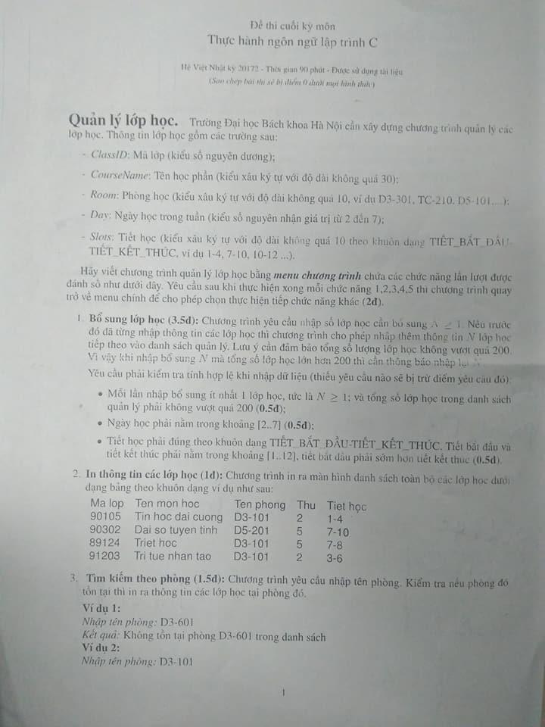

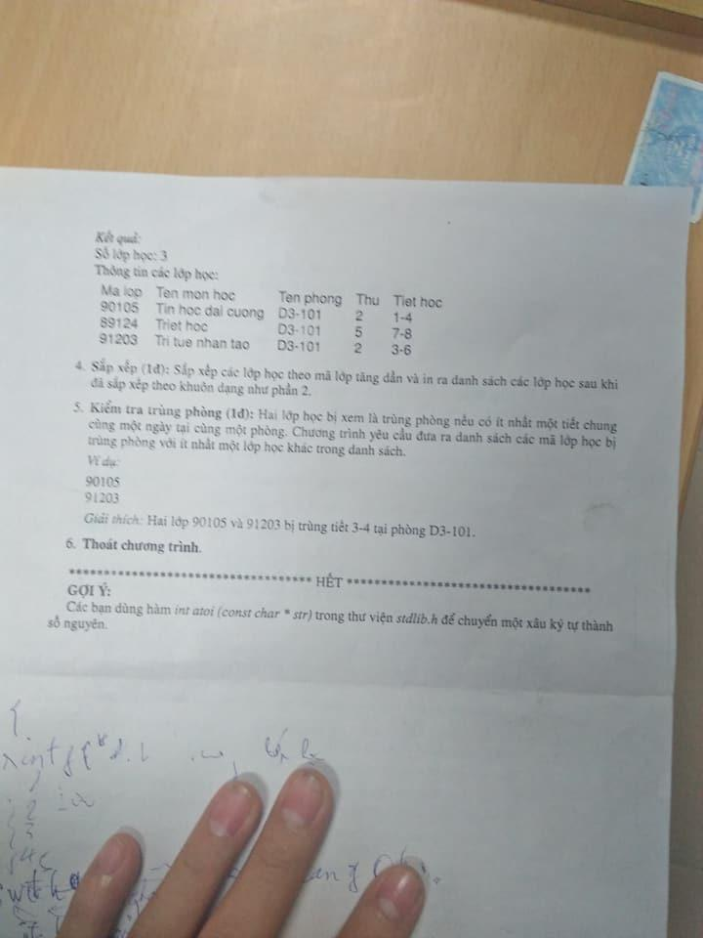

#include<stdio.h>

#include<string.h>

#include<stdlib.h>

typedef struct Classes

{

int ClassID;

char CourseName[30];

char Room[10];

char slots[10];

int Day;

}lop;

void nhap(lop*K,int n)

{

int i;

for(i=0;i<n;i++)

{

printf("Moi nhap ma lop hoc [%d]:\n",i+1);

scanf("%d",&K[i].ClassID);

printf("Nhap hoc phan [%d]:\n",i+1);

fflush(stdin);

gets(K[i].CourseName);

//printf("%d",atoi(K[i].CourseName));

printf("Nhap so phong [%d]:\n",i+1);

fflush(stdin);

gets(K[i].Room);

printf("Nhap ngay hoc cua lop [%d]:\n",i+1);

scanf("%d",&K[i].Day);

while(K[i].Day<2||K[i].Day>7)

{

printf("moi nhap lai ngay hoc cua lop [%d]:\n",i+1);

scanf("%d",&K[i].Day);

}

printf("Nhap ca hoc cua lop [%d]:\n",i+1);

fflush(stdin);

gets(K[i].slots);

}

}

void nhapthem(lop*K,int n,int j)

{

int i;

for(i=n-j;i<n;i++)

{

printf("Moi nhap ma lop hoc [%d]:\n",i+1);

scanf("%d",&K[i].ClassID);

printf("Nhap hoc phan [%d]:\n",i+1);

fflush(stdin);

gets(K[i].CourseName);

printf("Nhap so phong [%d]:\n",i+1);

fflush(stdin);

gets(K[i].Room);

printf("Nhap ngay hoc cua lop [%d]:\n",i+1);

scanf("%d",&K[i].Day);

while(K[i].Day<2||K[i].Day>7)

{

printf("moi nhap lai ngay hoc cua lop [%d]:\n",i+1);

scanf("%d",&K[i].Day);

}

printf("Nhap ca hoc cua lop [%d]:\n",i+1);

fflush(stdin);

gets(K[i].slots);

while(K[i].slots[1]!=45)

{

printf("Nhap lai ca hoc cua lop [%d]:\n",i+1);

fflush(stdin);

gets(K[i].slots);

}

}

}

int inra(lop*K,int n)

{

int i;

printf("%-10s | %-30s | %-10s | %-10s | %-10s | \n","Ma lop","Ten mon hoc","Ten phong","Thu","Tiet hoc");

for(i=0;i<n;i++)

{

printf("%-10d | %-30s | %-10s | %-10d | %-10s |\n",K[i].ClassID,K[i].CourseName,K[i].Room,K[i].Day,K[i].slots);

}

}

int timkiemtheophong(lop*K,int n)

{

int i,dem=0,j=0;

char search[10];

printf("Moi nhap ten phong can tim :\n");

fflush(stdin);

gets(search);

for(i=0;i<n;i++)

{

if(strcasecmp(K[i].Room,search)==0)

{

if(j==0)

{

printf("%-10s | %-30s | %-10s | %-10s | %-10s | \n","Ma lop","Ten mon hoc","Ten phong","Thu","Tiet hoc");

printf("%-10d | %-30s | %-10s | %-10d | %-10s |",K[i].ClassID,K[i].CourseName,K[i].Room,K[i].Day,K[i].slots);

printf("\n");

j++;

dem--;

}

else

{

printf("%-10d | %-30s | %-10s | %-10d | %-10s |\n",K[i].ClassID,K[i].CourseName,K[i].Room,K[i].Day,K[i].slots);

dem--;

}

}

dem++;

}

if(dem==n)

printf("Khong tim thay phong ban yeu cau !\n");

else printf("Co %d lop",n-dem);

}

void ranking(lop*K,int n)

{

lop K3[50],a;

int i,j;

for(i=0;i<n;i++)

{

K3[i]=K[i];

}

for(j=n-1;j>=0;j--)

{

for(i=0;i<j;i++)

{

if(K3[i].ClassID<K3[i+1].ClassID)

{

a=K3[i];

K3[i]=K3[i+1];

K3[i+1]=a;

}

}

}

printf("%-10s | %-30s | %-10s | %-10s | %-10s | \n","Ma lop","Ten mon hoc","Ten phong","Thu","Tiet hoc");

for(i=0;i<n;i++)

{

printf("%-10d | %-30s | %-10s | %-10d | %-10s |",K3[i].ClassID,K3[i].CourseName,K3[i].Room,K3[i].Day,K3[i].slots);

printf("\n");

}

}

void checking(lop*K,int n)

{

int i,j;

lop K2[50];

for(i=0;i<strlen(K[i].slots)-2;i++)

{

K2[i].slots[i]=K[i].slots[i+2];

}

for(i=0;i<n;i++)

{

for(j=1;j<n;j++)

{

if(strcmp(K[i].Room,K[i+j].Room)==0)

{

if(K[i].Day==K[i+j].Day)

{

if(atoi(K2[i].slots)-atoi(K[i+j].slots)>0)

printf("\n%d\n%d\nGiai thich: 2 lop %d va %d bi trung tiet %d-%d ngay thu %d tai phong %-10s ",K[i].ClassID,K[i+j].ClassID,K[i].ClassID,K[i+j].ClassID,atoi(K[i+j].slots),atoi(K2[i].slots),K[i].Day,K[i].Room);

if(atoi(K2[i].slots)-atoi(K[i+j].slots)==0)

printf("\n%d\n%d\nGiai thich: 2 lop %d va %d bi trung tiet %d ngay thu %d tai phong %-10s ",K[i].ClassID,K[i+j].ClassID,K[i].ClassID,K[i+j].ClassID,atoi(K2[i].slots),K[i].Day,K[i].Room);

}

}

}

}

}

int main()

{

int m,n=0,j=0;

lop K[50];

while(m!=6)

{

printf("\nMenu\n1.Bo sung lop hoc.\n2.In ra thong tin cac lop hoc.\n3.Tim kiem theo phong.\n4.Sap xep.\n5.Kiem tra trung phong.\n6.Thoat\n");

scanf("%d",&m);

switch(m)

{

case 1:

if(n==0)

{

printf("Nhap so lop muon in thong tin:\n");

scanf("%d",&n);

while(n<1||n>200)

{

printf("Ban da nhap sai, moi nhap lai so lop muon in thong tin:\n");

scanf("%d",&n);

}

nhap(K,n);

}

else

{

printf("Nhap so lop muon nhap them :\n");

scanf("%d",&j);

while(j<=0)

{

printf("Ban da nhap sai, moi nhap lai so lop muon in thong tin:\n");

scanf("%d",&j);

}

while(n+j>200)

{

printf("Ban da nhap sai, moi nhap lai so lop muon in thong tin them:\n");

scanf("%d",&j);

}

n+=j;

nhapthem(K,n,j);

}

break;

case 2:

inra(K,n);

break;

case 3:

timkiemtheophong(K,n);

break;

case 4:

ranking(K,n);

break;

case 5:

checking(K,n);

break;

case 6:

printf("Goodbye!.....");

break;

default: printf("Error, please enter again!\n");

}

}

}

**Đề K63**

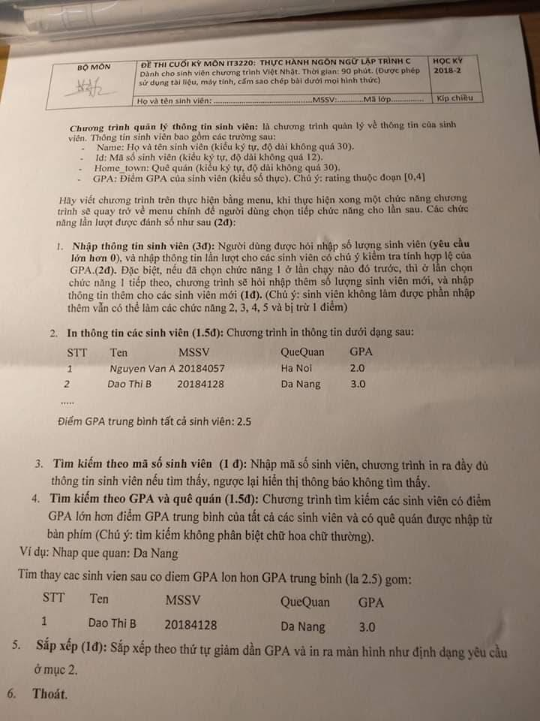

#include<stdio.h>

#include<string.h>

#include<stdlib.h>

typedef struct SINHVIEN

{

char ten[50],quequan[30];

char mssv[12];

float CPA;

}SV;

void nhap(SV*K, int n)

{

int i;

for(i=0;i<n;i++)

{

fflush(stdin);

printf("Ho ten sinh vien[%d] = ",i+1);

gets(K[i].ten);

printf("Que quan sinh vien[%d] = ",i+1);

gets(K[i].quequan);

printf("MS sinh vien[%d] = ",i+1);

gets(K[i].mssv);

printf("CPA sinh vien[%d] = ",i+1);

scanf("%f",&K[i].CPA);

while(K[i].CPA<0||K[i].CPA>4.0)

{

printf("Nhap lai CPA > 0\n ");

scanf("%f",&K[i].CPA);

}

}

}

void nhapthem(SV*K, int n,int j)

{

int i;

for(i=n-j;i<n;i++)

{

fflush(stdin);

printf("Ho ten sinh vien[%d] = ",i+1);

gets(K[i].ten);

printf("Que quan sinh vien[%d] = ",i+1);

gets(K[i].quequan);

printf("MS sinh vien[%d] = ",i+1);

gets(K[i].mssv);

printf("CPA sinh vien[%d] = ",i+1);

scanf("%f",&K[i].CPA);

while(K[i].CPA<0||K[i].CPA>4.0)

{

printf("Nhap lai CPA > 0\n ");

scanf("%f",&K[i].CPA);

}

}

}

int inra(SV*K,int n){

int i;

float tong=0;

printf("%-10s | %-20s | %-10s | %-10s | %5s\n","STT","Ten","Que Quan","MSSV","CPA");

for(i=0;i<n;i++){

printf("%-10d | %-20s | %-10s | %-10s | %5.2f",i+1,K[i].ten,K[i].quequan,K[i].mssv,K[i].CPA);

printf("\n");

tong+=K[i].CPA;

}

printf("\nCPA trung binh cua SV la %.2f\n",tong/n);

}

void tracuu(SV*K,int n)

{

char timkiem[12];

int i;

int dem;

printf("Nhap mssv can tim : ");

fflush(stdin);

gets(timkiem);

for(i=0,dem=0;i<n;i++)

{

if(strcmp(timkiem,K[i].mssv)==0)

{

if(dem==0)

{

printf("%-10s | %-20s | %-10s | %-10s | %5s\n","STT","Ten","Que Quan","MSSV","CPA");

}

printf("%-10d | %-20s | %-10s | %-10s | %5.2f",i+1,K[i].ten,K[i].quequan,K[i].mssv,K[i].CPA);

printf("\n");

dem++;

}

}

if(dem==0)

printf("Khong tim thay sinh vien can tim !\n");

}

/*int tracuutheoquequan(SV*K,int n)

{

int k=0,x=0;

float tong=0;

char search[30];

printf("Nhap que quan sinh vien can tim : ");

fflush(stdin);

gets(search);

int i,j;

int dem;

for(i=0;i<n;i++)

{

tong+=K[i].CPA;

}

for(i=0;i<n;i++)

{

dem=0;

if(K[i].CPA>=tong/n)

{

for(j=0;j<strlen(K[i].quequan)-1;j++)

{

if(K[i].quequan[j]==search[j]||K[i].quequan[j]+32==search[j]|K[i].quequan[j]-32==search[j])

{

dem++;

}

}

}

if(dem==strlen(K[i].quequan)-1)

{

if(k==0)

{

printf("%-10s | %-20s | %-10s | %-10s | %5s\n","STT","Ten","Que Quan","MSSV","CPA");

k++;

}

if(k>0)

{

printf("%-10d | %-20s | %-10s | %-10s | %5.2f\n",i+1,K[i].ten,K[i].quequan,K[i].mssv,K[i].CPA);

x--;

}

}

x++;

}

if(x==n)

{

printf("Khong tim thay sv co que quan va CPA tren tb \n");

}

}*/

int tracuutheoquequan2(SV*K,int n)

{

int k=0,x=0;

float tong=0;

char search[30];

printf("Nhap que quan sinh vien can tim : ");

fflush(stdin);

gets(search);

int i,j;

int dem;

for(i=0;i<n;i++)

{

tong+=K[i].CPA;

}

for(i=0;i<n;i++)

{

if(K[i].CPA>=tong/n)

{

if(strcasecmp(K[i].quequan,search)==0)

{

if(k==0)

{

printf("%-10s | %-20s | %-10s | %-10s | %5s\n","STT","Ten","Que Quan","MSSV","CPA");

k++;

}

if(k>0)

{

printf("%-10d | %-20s | %-10s | %-10s | %5.2f\n",i+1,K[i].ten,K[i].quequan,K[i].mssv,K[i].CPA);

x--;

}

}

}

x++;

}

if(x==n)

{

printf("Khong tim thay sv co que quan va CPA tren tb \n");

}

}

void sapxep(SV*K,int n)

{

int i,j;

SV K2[n],a;

char N[30];

for(i=0;i<n;i++)

{

K2[i]=K[i];

}

for(j=n;j>=0;j--)

{

for(i=0;i<j;i++)

{

if(K2[i].CPA<K2[i+1].CPA)

{

a=K2[i];

K2[i]=K2[i+1];

K2[i+1]=a;

}

}

}

printf("%-10s | %-20s | %-10s | %-10s | %5s\n","STT","Ten","Que Quan","MSSV","CPA");

for(i=0;i<n;i++)

{

printf("\n");

printf("%-10d | %-20s | %-10s | %-10s | %5.2f",i+1,K2[i].ten,K2[i].quequan,K2[i].mssv,K2[i].CPA);

}

}

int main()

{

SV K[100];

int j=0,n=0,m = 0;

while(m != 6)

{

printf("MENU\n1. Nhap thong tin sinh vien.\n2. In ra thong tin sinh vien.\n3.Tim kiem thong tin sinh vien qua mssv.\n4.Tim kiem thong tin sinh vien qua quequan.\n5.In ra bang xep hang CPA tu cao den thap .\n6.Thoat chuong trinh.\n");

scanf("%d",&m);

switch (m)

{

case 1:

if(n==0)

{

j=0;

printf("Nhap so sinh vien : ");

scanf("%d",&n);

nhap(K,n);

}

else

{

printf("Nhap so sinh vien muon nhap them :\n");

scanf("%d",&j);

n+=j;

nhapthem(K,n,j);

}

while(n<=0)

{

printf("So sinh vien khong nho hon 0\nNhap lai n = ");

scanf("%d",&n);

}

break;

case 2:

if(n == 0){

printf("Nhap 1\n");

}

else

{

inra(K,n);

}

break;

case 3:

tracuu(K,n);

break;

case 4:

tracuutheoquequan2(K,n);

break;

case 5:

sapxep(K,n);

break;

case 6:

printf("Goodbye !");

break;

default : printf("........");

}

}

}

**Đề K59(2015)**

#include<stdio.h>

#include<string.h>

#include<stdlib.h>

typedef struct SINHVIEN

{

char ten[30];

char name[30];

char mssv[5];

float hd[3];//diem cua 3 thanh vien hoi dong

float HD,PB;//diem cua gv huong dan va gvien phan hieu

float gk;

float ck;

}SV;

int kiemtraten(char a[])

{

int i;

if(a[0]>=97&&a[0]<=122)

a[0]-=32;

for(i=1;i<strlen(a)-1;i++)

{

if(a[i]==' ')

{

switch(a[i+1])//auto viet hoa chu cai dau trong ho ten

{

case 97 ... 122 :

a[i+1]-=32;

break;

default : continue;

}

}

}

if(strstr(a," ")==NULL)

{

return 1;

}

else

{

if(a[strlen(a)-1]==' ')

return 1;

else return 0;

}

}

int checkmssv(SV*K,int k)

{

int i;

for(i=0;i<k;i++)

{

if(strcmp(K[i].mssv,K[k-1].mssv)==0&&i!=k-1)

{

return 1;

}

}

return 0;

}

void nhap(SV*K,int n)

{

int i,j;

for(i=0;i<n;i++)

{

K[i].ck=0;

printf("Thong tin sinh vien %d :\n",i+1);

printf("Ho ten :__");

fflush(stdin); gets(K[i].ten);

while(kiemtraten(K[i].ten)!=0)

{

printf("Nhap lai Ho ten :__");

fflush(stdin); gets(K[i].ten);

}

printf("MSSV :__");

fflush(stdin); gets(K[i].mssv);

while(checkmssv(K,i+1)==1)

{

printf("Nhap lai MSSV :__");

fflush(stdin); gets(K[i].mssv);

}

printf("Diem cua gv huong dan :__");

scanf("%f",&K[i].HD);

while(K[i].HD<0||K[i].HD>10)

{

printf("Error! Moi nhap lai diem gv huong dan :__");

scanf("%f",&K[i].HD);

}

printf("Diem cua gv phan hieu :__");

scanf("%f",&K[i].PB);

while(K[i].PB<0||K[i].PB>10)

{

printf("Error! Moi nhap lai diem gv phan hieu :__");

scanf("%f",&K[i].PB);

}

for(j=0;j<3;j++)

{

printf("Nhap diem cua hoi dong %d:__",j+1);

scanf("%f",&K[i].hd[j]);

while(K[i].hd[j]<0||K[i].hd[j]>10)

{

printf("Error! Moi nhap lai diem hoi dong %d :__",j+1);

scanf("%f",&K[i].hd[j]);

}

K[i].ck+=K[i].hd[j];

}

K[i].gk=0.5*(K[i].HD+K[i].PB);

if(K[i].hd[0]<5.5||K[i].hd[1]<5.5||K[i].hd[2]<5.5)

{

K[i].ck=0;

}

if(K[i].HD<5.5||K[i].PB<5.5)

{

K[i].gk=0;

}

}

int dem=0;

for(i=0;i<n;i++)

{

if(dem==0)

{

printf("%-5s %-30s %-5s %-5s %-5s %-5s %-5s %-5s %-5s\n","MSSV","Ho ten sv","HD","PB","HD1","HD2","HD3","GK","CK");

printf("%-5s %-30s %-5.1f %-5.1f %-5.1f %-5.1f %-5.1f %-5.1f %-5.1f\n",K[i].mssv,K[i].ten,K[i].HD,K[i].PB,K[i].hd[0],K[i].hd[1],K[i].hd[2],K[i].gk,K[i].ck/3);

dem++;

}

else

printf("%-5s %-30s %-5.1f %-5.1f %-5.1f %-5.1f %-5.1f %-5.1f %-5.1f\n",K[i].mssv,K[i].ten,K[i].HD,K[i].PB,K[i].hd[0],K[i].hd[1],K[i].hd[2],K[i].gk,K[i].ck/3);

}

}

void nhapthem(SV*K,int n,int k)

{

int i,j;

for(i=n-k;i<n;i++)

{

K[i].ck=0;

printf("Thong tin sinh vien %d :\n",i+1);

printf("Ho ten :__");

fflush(stdin); gets(K[i].ten);

while(kiemtraten(K[i].ten)!=0)

{

printf("Nhap lai Ho ten :__");

fflush(stdin); gets(K[i].ten);

}

printf("MSSV :__");

fflush(stdin); gets(K[i].mssv);

while(checkmssv(K,i+1)==1)

{

printf("Nhap lai MSSV :__");

fflush(stdin); gets(K[i].mssv);

}

printf("Diem cua gv huong dan :__");

scanf("%f",&K[i].HD);

while(K[i].HD<0||K[i].HD>10)

{

printf("Error! Moi nhap lai diem gv huong dan :__");

scanf("%f",&K[i].HD);

}

printf("Diem cua gv phan hieu :__");

scanf("%f",&K[i].PB);

while(K[i].PB<0||K[i].PB>10)

{

printf("Error! Moi nhap lai diem gv phan hieu :__");

scanf("%f",&K[i].PB);

}

for(j=0;j<3;j++)

{

printf("Nhap diem cua hoi dong %d:__",j+1);

scanf("%f",&K[i].hd[j]);

while(K[i].hd[j]<0||K[i].hd[j]>10)

{

printf("Error! Moi nhap lai diem hoi dong %d :__",j+1);

scanf("%f",&K[i].hd[j]);

}

K[i].ck+=K[i].hd[j];

}

K[i].gk=0.5*(K[i].HD+K[i].PB);

if(K[i].hd[0]<5.5||K[i].hd[1]<5.5||K[i].hd[2]<5.5)

{

K[i].ck=0;

}

if(K[i].HD<5.5||K[i].PB<5.5)

{

K[i].gk=0;

}

}

int dem=0;

for(i=0;i<n;i++)

{

if(dem==0)

{

printf("%-5s %-30s %-5s %-5s %-5s %-5s %-5s %-5s %-5s\n","MSSV","Ho ten sv","HD","PB","HD1","HD2","HD3","GK","CK");

printf("%-5s %-30s %-5.1f %-5.1f %-5.1f %-5.1f %-5.1f %-5.1f %-5.1f\n",K[i].mssv,K[i].ten,K[i].HD,K[i].PB,K[i].hd[0],K[i].hd[1],K[i].hd[2],K[i].gk,K[i].ck/3);

dem++;

}

else

printf("%-5s %-30s %-5.1f %-5.1f %-5.1f %-5.1f %-5.1f %-5.1f %-5.1f\n",K[i].mssv,K[i].ten,K[i].HD,K[i].PB,K[i].hd[0],K[i].hd[1],K[i].hd[2],K[i].gk,K[i].ck/3);

}

}

void tachornot(SV*K,int n)

{

int i,dem=0;

for(i=0;i<n;i++)

{

if(K[i].gk!=0&&K[i].ck!=0)

{

printf("%-5s %-30s %-5.1f %-5.1f %-5.1f %-5.1f %-5.1f %-5.1f %-5.1f\n",K[i].mssv,K[i].ten,K[i].HD,K[i].PB,K[i].hd[0],K[i].hd[1],K[i].hd[2],K[i].gk,K[i].ck/3);

dem--;

}

dem++;

}

if(dem==n)

{

printf("Ko ai bao ve thanh cong =((\n");

}

}

/*void sortten(SV*K,int n) ( hàm này của Dương, nếu hiểu code thì dùng)

{

SV b[30];

int i, j;

int count;

for(i = 0; i < n; i++){

count = 0;

j = strlen(K[i].ten)-1;

while(K[i].ten[j] != ' '){

count++;

j--;

}

int k = 0;

while(count >= 0){

b[i].ten[k] = K[i].ten[strlen(K[i].ten) - count];

k++;

count--;

}

}

SV tg;

for(i = n-1; i >= 0; i--){

for(j = 0; j < i; j++){

if(strcmp(b[j].ten, b[j+1].ten) > 0){

tg = K[j];

K[j] = K[j+1];

K[j+1] = tg;

}

}

}

printf("%-5s %-30s %-5s %-5s %-5s %-5s %-5s %-5s %-5s\n","MSSV","Ho ten sv","HD","PB","HD1","HD2","HD3","GK","CK");

for(i = 0; i < n; i++){

printf("%-5s %-30s %-5.1f %-5.1f %-5.1f %-5.1f %-5.1f %-5.1f %-5.1f\n",K[i].mssv,K[i].ten,K[i].HD,K[i].PB,K[i].hd[0],K[i].hd[1],K[i].hd[2],K[i].gk,K[i].ck/3);

}

}*/

char * timten( char* hoten)// ham tach ten khoi ho ten duoc nhap vao

{

int i;

i = strlen(hoten)-1;

/* tim ki tu trang cuoi cung trong xau */

while (i >= 0 && hoten[i] != ' ') i--;

return hoten + i + 1;

}

void sortten2(SV*K,int n)

{

int i,j;

SV K2[50],tmp;

for(i=0;i<n;i++)

{

strcpy(K[i].name,timten(K[i].ten));// gan name bang ten vua tach tu ho ten

}

for(i=0;i<n;i++)

{

K2[i]=K[i];

}

for(j=n-1;j>0;j--)

{

for(i=0;i<j;i++)

{

if(strcmp(K2[i].name,K2[i+1].name)>0)

{

tmp=K2[i];

K2[i]=K2[i+1];

K2[i+1]=tmp;

}

}

}

printf("%-5s %-30s %-5s %-5s %-5s %-5s %-5s %-5s %-5s\n","MSSV","Ho ten sv","HD","PB","HD1","HD2","HD3","GK","CK");

for(i = 0; i < n; i++)

{

printf("%-5s %-30s %-5.1f %-5.1f %-5.1f %-5.1f %-5.1f %-5.1f %-5.1f\n",K2[i].mssv,K2[i].ten,K2[i].HD,K2[i].PB,K2[i].hd[0],K2[i].hd[1],K2[i].hd[2],K2[i].gk,K2[i].ck/3);

}

}

int main()

{

int m,n=0,j;

SV K[20];

while(m!=4)

{

printf("\nMenu\n1.Bo sung sinh vien\n2.Danh sach sv bao ve thanh cong\n3.Sap xep theo ten sinh vien\n4.Thoat\n");

scanf("%d",&m);

switch(m)

{

case 1 :

if(n==0)

{

printf("Nhap so sinh vien muon them :__");

scanf("%d",&n);

while(n<0||n>20)

{

printf("Nhap lai so sinh vien muon them :__");

scanf("%d",&n);

}

nhap(K,n);

}

else

{

printf("Nhap so sinh vien muon nhap them :__");

scanf("%d",&j);

n+=j;

while(n<0||n>20)

{

printf("Nhap lai so sinh vien muon them :__");

scanf("%d",&j);

}

nhapthem(K,n,j);

}

break;

case 2:

tachornot(K,n);

break;

case 3:

sortten2(K,n);

break;

case 4: printf("Goodbye !____-");

break;

default: printf("Error!___Try Again__!");

}

}

}

**Đề K63(2)**

//de k63 20182

#include<stdio.h>

#include<string.h>

#include<stdlib.h>

typedef struct {

int phan_nguyen;

int tu_so;

int mau_so;

} hon_so;

void so1(int n)

{

int a[50][50];

int i,j;

int dem=0;

int temp=0;

for(i=0;i<n;i++)

{

for(j=0;j<n;j++)

{

printf("Nhap a[%d][%d]=",i+1,j+1);

scanf("%d",&a[i][j]);

}

}

printf("ma tran vua nhap la:\n");

for(i=0;i<n;i++)

{

for(j=0;j<n;j++)

{

printf("%d ",a[i][j]);

}

printf("\n");

}

for(i=0;i<n;i++)

{

if(a[i][i]==1)

{

dem+=1;

}

}

for(i=0;i<n;i++)

{

for(j=0;j<n;j++)

{

if(a[i][j]==0)

{

temp+=1;

}

}

}

if(dem==n&&temp==n*(n-1))

{

printf("Ma tran vua nhap chinh la ma tran don vi\n");

}

else printf("Ma tran vua nhap khong phai ma tran don vi %d!",dem);

}

void so3()

{

char A[12];

printf("Moi nhap so dien thoai :");

fflush(stdin);

gets(A);

while(strlen(A)<10||strlen(A)>11)

{

printf("Moi nhap lai so dien thoai :");

fflush(stdin);

gets(A);

}

int i;

int n=1;

if(strlen(A)>11)

{

A[11]='\0';

}

// while(n==1)

step_1:

switch(A[0])

{

case '1':

if(A[1]=='6')

{

A[0]=' ';

A[1]='3';

n=2;

printf("So dien thoai moi la :\n %s",A);

}

else

{

if(strlen(A)==11)

{

printf("Khac nha mang !");

}

}

break;

case '0':

for(i=0;i<11;i++)

{

A[i]=A[i+1];

if(i==10)

{

A[i]='\0';

}

}

goto step_1;

break;

default:

if(strlen(A)!=10)

printf("Khac nha mang !");

}

}

/*---Ham nhap hon so---*/

void nhap_hon_so(hon_so *a, int n){

int i;

for(i = 0; i < n; i++){

printf("Hon so thu - %d: \n", i+1);

printf("Phan nguyen: "); scanf("%d", &a[i].phan_nguyen);

printf("Tu so: "); scanf("%d", &a[i].tu_so);

printf("Mau so: "); scanf("%d", &a[i].mau_so);

}

}

/*---Ham tinh thuong cua 2 hon so---*/

void thuong(hon_so x1, hon_so x2){

hon_so a;

if(x2.tu_so == 0){

printf("Invalid\n");

return ;

}

a.phan_nguyen = ((x1.phan_nguyen*x1.mau_so + x1.tu_so) * x2.mau_so) / (x1.mau_so*(x2.phan_nguyen*x2.mau_so + x2.tu_so));

a.mau_so = x1.mau_so*(x2.phan_nguyen*x2.mau_so + x2.tu_so);

a.tu_so = ((x1.phan_nguyen*x1.mau_so + x1.tu_so) * x2.mau_so) - (a.phan_nguyen * a.mau_so);

printf("%d %d/%d", a.phan_nguyen, a.tu_so, a.mau_so);

}

void so2(char*k,int n)

{

int i,j,q;

if(k[0]=='X')

{

for(i=1;i<=n;i++)

{

printf("\n");

for (j=1;j<=n-i;j++) printf(" ");

for (j=1;j<=i;j++) printf(" * ");

for(j=i-1; j>=1;j--) printf(" * ");

}

}

if(k[0]=='N')

{

for(i=1;i<=n;i++)

{

printf("\n");

for(q=2;q<=i;q++)

{

printf(" ");

}

for (j=1;j<=n-i+1;j++) printf(" * ");

for (j=1;j<=n-i;j++) printf(" * ");

}

}

}

int main()

{

hon_so hs[2];

int m,n;

char k[2];

while(m!=5)

{

printf("\nMenu\n1.Kiem tra ma tran don vi\n2.Tam giac xuoi nguoc\n3.Chuyen so dien thoai\n4.Phan so\n5.Thoat\n");

scanf("%d",&m);

switch(m)

{

case 1 :

printf("Nhap cap cua ma tran :___");

scanf("%d",&n);

while(n<0)

{

printf("Moi nhap lai cap cua ma tran : \n");

scanf("%d",&n);

}

so1(n);

break;

case 2 :

printf("Enter N =");

scanf("%d",&n);

printf("Enter X or N :");

scanf("%s",&k);

so2(k,n);

break;

case 3:

so3();

break;

case 4:

nhap_hon_so(hs, 2);

thuong(hs[0], hs[1]);

break;

case 5:

printf("Goodbye!_____");

break;

default: printf("Error! Please Try Again!____");

}

}}